Consultation Questionnaire Exemptions 6(a) and 6(a)(I) of RoHS Annex III
Table 1 shows the current wording of the exemptions on Annex III of the RoHS Directive.
Table 1: Currently valid wordings of exemptions III-6(a) and III-6(a)(I)
No. | Current exemption wording | Current scope and dates of applicability
III-6(a) | Lead as an alloying element in steel for machining purposes and in galvanised steel containing up to 0,35 % lead by weight | Applies to categories 8, 9 and 11.  Expires on  - 21 July 2021 for cat. 8 other than in-vitro diagnostic medical devices, and cat. 9 other than industrial monitoring and control instruments  - 21 July 2023 for category 8 in-vitro diagnostic medical devices  - 21 July 2024 for category 9 industrial monitoring and control instruments, and for category 11
III-6(a)(I) | Lead as an alloying element in steel for machining purposes containing up to 0,35 % lead by weight and in batch hot dip galvanised steel components containing up to 0,2 % lead by weight | Applies to categories 1 to 7 and 10  Expires on 21 July 2021 for categories 1 to 7 and 10.

ACRONYMS AND DEFINITIONS
COM European Commission
EEE Electrical and electronic equipment
IMCI Industrial monitoring and control instruments

Background and objectives of this review
Bio Innovation Service, UNITAR-SCYCLE and Fraunhofer IZM have been appointed by the European Commission for the evaluation of applications for new exemptions and the renewal of exemptions currently listed in Annexes III and IV of the RoHS Directive 2011/65/EU.
EUROMOT and TMC requested the renewal of exemption 6(a) with its current wording for the maximum validity periods for cat. 11 and cat. 9 industrial monitoring and control instruments (IMCI). The National Association of Manufacturers (NAM) support EUROMOT’s request. The applicants were requested to respond to clarification questionnaires prior to this stakeholder consultation to provide missing information. These questionnaires, along with the exemption applications, and – if submitted - supporting evidence from other stakeholders, are accessible on the consultation web page.
The stakeholder consultation is part of the review process for the exemption request at hand. It addresses third parties – not the applicants – to provide and to evaluate information and evidence according to the criteria listed in Art. 5(1)(a) of Directive 2011/65/EU.
Exemptions 6(a) and 6(a)(I) were reviewed by Baron et al. (2022) resulting in the below recommendation.
Table 2: Proposed renewal of exemptions 6(a) and 6(a)(I) in the last review in 2022
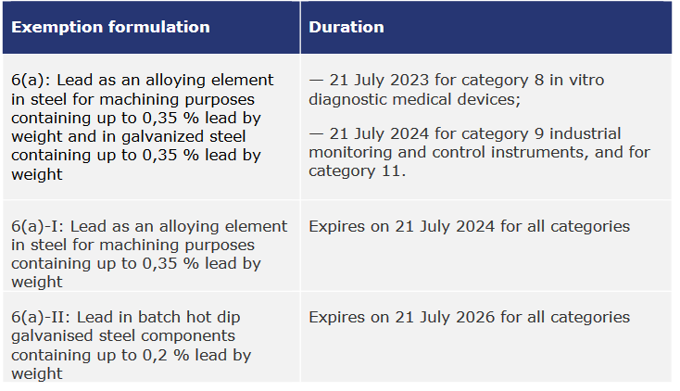
Source: Baron et al. (2022)
The European Commission (COM) have not yet officially published their decision as to the adoption of the above recommendation. The COM wishes the consultants to assess in this current review round whether there are any substantial reasons in line with Art. 5(1)(a) against the adoption of the above recommendation for EEE of categories 8, 9 and 11 (RoHS Annex I). This implies that the consultants will assess whether the validities of exemptions whose renewal is requested for cat. 8, 9 or 11 may exceed the validities recommended in the previous review (Table 2). Table 3 reflects the potential scope and wording if the exemptions are renewed for cat. 9 industrial monitoring and control instruments (IMCI) and for cat. 11.
Table 3: Renewal of exemption 6(a)-series for cat. 9 IMCI and cat. 11
No. | Exemption | Scope and dates of applicability
III-6(a) | Lead as an alloying element in steel for machining purposes and in galvanised steel containing up to 0,35 % lead by weight | Applies to categories 8, 9 and 11.  Expires on  - 21 July 2023 for category 8 in-vitro diagnostic medical devices  - 21 July 2024 for category 9 industrial monitoring and control instruments, and for category 11
III-6(a)(I) | Lead as an alloying element in steel for machining purposes containing up to 0,35 % lead by weight | Applies to categories 1 to 11.  Expires on  - 21 July (2024+A) for cat. 9 industrial monitoring and control instruments  - 21 July (2024+ C) for cat. 11  - 21 July 2024 for all other categories
III-6(a)(II) | Lead in batch hot dip galvanised steel components containing up to 0,2 % lead by weight | Applies to categories 1 to 11.  Expires on  - 21 July (2026 + B) for cat. 9 industrial monitoring and control instruments  - 21 July (2026 + D) for cat. 11  - 21 July 2026 for all other categories
A can range between 0 and 7 years.
B and C can range between 0 and 5 years.
D can range between 0 and 3 years.
To contribute to this stakeholder consultation, please answer the below questions until 11 December 2023.
Please also see the applicants’ request form and clarification questionnaire response and – if submitted – further information on the consultation web page.

Questions
- In their answers to the clarification questionnaire EUROMOT agree that exemption 6(a)(I) would cover their applications of lead in EEE of cat. 11 provided that the exemption would remain valid for five years, i.e. until 2029. They further on state that no additional time is to be permitted for exemption 6(a)(II) so that it can expire in 2026 for cat. 11.
  - In case you do not agree to EUROMOT’s above conclusions, please support your views with detailed technical argumentation / evidence in line with the criteria in Art. 5(1)(a).

  - Do you agree that that exemption is required for cat. 11 for another five years until 2029? Please provide arguments and evidence for your opinion.

  - Are you aware of lead-free substitutes being used in EEE of cat. 11 in applications that are in the scope of the requested exemption?

- TMC claim that the recommendations of Baron et al. (2022) in Table 2 which are specified in Table 3 are not applicable to cat. 9 IMCI. It is understood that this disagreement refers to the exemption wordings regardless of the potential renewal period, and that the arguments against the adoption of exemptions 6(a)(I) and 6(a)(II) are at least partially based on additional administrative burdens which this may cause.
From the technical perspective, compared to exemption 6(a) the proposed exemption 6(a)(I) does not restrict the scope for lead in steel for machining purposes. Restrictions apply to galvanised steel in exemption 6(a)(II), which limits the scope to batch hot dip galvanised steel and reduces the maximum allowed lead concentration to 0.2 % down from 0.35 % in exemption 6(a).
  - Since the use of lead in galvanised steel is not mentioned in TMC’s renewal request, the question arises whether it is relevant for cat. 9 IMCI. Please comment.

  - If galvanised steel is relevant for cat. 9 IMCI, is exemption 6(b)(II) technically applicable to cat. 9 IMCI?

  - If it is applicable, can exemption 6(b)(II) expire on 21 July 2026 for cat. 9 IMCI like in the case of cat. 11?

- Are you aware of lead-free substitutes that are used in cat. 9 industrial monitoring and control instruments?

- TMC provided a socioeconomic analysis related to lead in steel for machining purposes, i.e. lead in galvanised steel is not addressed. The document is available online in the consultation folder for this exemption.
Do you agree with the underlying method, data and conclusions?

- Is there any additional information which you would like to provide?

Please note that answers to these questions can be published on the stakeholder consultation website and in the review report. If your answers contain confidential information, please provide a version that can be made public along with a confidential version, in which proprietary information is clearly marked.
Please do not forget to provide your contact details (Name, Organisation, e-mail and phone number) so that the project team can contact you in case there are questions concerning your contribution.
It would be helpful for the review process if you could kindly provide the information in formats that allow copying text, figures and tables to be included in the review report.

It is implemented through the specific contract 070201/2020/832829/ENV.B.3 under the Framework contract ENV.B.3/FRA/2019/0017
Consultation web page: https://rohs.biois.eu/requests2.html
Directive 2011/65/EU (RoHS) available at http://eur-lex.europa.eu/LexUriServ/LexUriServ.do?uri=CELEX:32011L0065:EN:NOT
C.f. Öko-Institut, https://rohs.exemptions.oeko.info/fileadmin/user_upload/RoHS_Pack_22/RoHS_Pack-22_final_report_amended_February_2022.pdf
Consultation web page: https://rohs.biois.eu/requests2.html

