Consultation Questionnaire Exemption 7(c)(I) of RoHS Annex III

Table 1: Currently valid wording of the exemption
No. | Exemption | Scope and dates of applicability
III-7(c)(I) | Electrical and electronic components containing lead in a glass or ceramic other than dielectric ceramic in capacitors, e.g. piezoelectronic devices, or in a glass or ceramic matrix compound | Applies to categories 1 to 11 (except applications covered under point 34) and expires on  - 21 July 2021 for categories 1-7 and 10, and for category 8 other than in vitro diagnostic medical devices and cat. 9 other than industrial monitoring and control instruments  - 21 July 2023 for category 8 in vitro diagnostic medical devices;  - 21 July 2024 for category 9 industrial monitoring and control instruments, and for category 11

Acronyms and Definitions
Cat. Category, referring to the categories of EEE specified in Annex II of the current RoHS Directive
COM European Commission
EEE Electrical and electronic equipment
IMCI Industrial monitoring and control instruments
Lead-free Not containing lead in the application in scope of the exemption to be reviewed
NRMM Non-road mobile machinery (NRMM)
Pb Lead

Background and objectives of this review
Bio Innovation Service, UNITAR-SCYCLE and Fraunhofer IZM have been appointed by the European Commission for the evaluation of applications for new exemptions and the renewal of exemptions currently listed in Annexes III and IV of the RoHS Directive 2011/65/EU.
TMC requested the renewal of the exemption with its current wording for the maximum validity of 7 years for cat. 9 industrial monitoring and control instruments (IMCIs). Werfen asked for a 5 year renewal of the exemption for cat. 8 in-vitro diagnostic medical devices (IVDs) for the analysis of whole blood. In their clarification questionnaire, Werfen explained that tests conducted between the time of the exemption application and the time when the clarifcation questionnaire was answered, showed that lead-free alternatives w did not perform as expected. Werfen therefore amendeded their exemption request asking for a 7 year duration for the renewed exemption.
EUROMOT wish the exemption to be renewed for the maximum valdity period of 5 years for use in specific parts of cat. 11 equipment (engines, engine components and ancillary components and in end-products in which they are used).
The applicants were requested to respond to clarification questionnaires prior to this stakeholder consultation to complete missing information. These questionnaires along with the exemption applications and – if submitted - supporting evidence and information from other stakeholders are accessible on the online consultation web page.
The stakeholder consultation is part of the review process for the exemption request at hand. It addresses third parties – not the applicants – to provide and to evaluate information and evidence according to the criteria listed in Art. 5(1)(a) of Directive 2011/65/EU.
Exemption 7(c)(I) was reviewed by Baron et al. (2022), who recommended to renew the exemption as illustrated in the below table.
Table 2: Recommended renewal of exemption 7(c)(I) in the last review in 2022
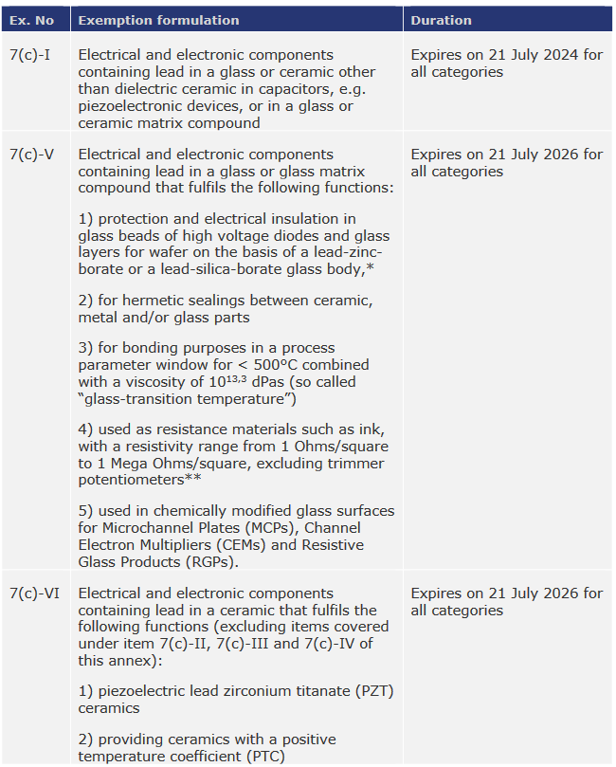
Source: Baron et al. (2022)
The European Commission (COM) have not yet officially published their decision as to the adoption of the above recommendation. The COM wishes the consultants to assess in this current review round whether there are any substantial reasons in line with Art. 5(1)(a) against the adoption of the above recommendation for EEE of categories 8, 9 and 11. This implies that the consultants will assess whether the validities of exemptions whose renewal is requested for cat. 8, 9 or 11 may exceed the validities recommended in the previous review (Table 2). Table 3 reflects the potential scope and wordings if the exemptions are recommended to be renewed for cat. 8 IVDs for the analysis of whole blood, cat. 9 IMCI, and for cat. 11.
Table 3: Renewal of current exemption 7(c)(I) for cat. 8, 9 and 11 based on the recommendation of the last review in 2021/2022
No. | Recommended Exemption | Recommended scope and dates of applicability
III-7(c)(I) | Electrical and electronic components containing lead in a glass or ceramic other than dielectric ceramic in capacitors, e.g. piezoelectronic devices, or in a glass or ceramic matrix compound | Applies to categories 1 to 11.  Expires on 21 July 2024 for categories 1 to 11.
III-7(c)(V) | Electrical and electronic components containing lead in a glass or glass matrix compound that fulfils the following functions:  - protection and electrical insulation in glass beads of high voltage diodes and glass layers for wafer on the basis of a lead-zinc-borate or a lead-silica-borate glass body,*  - for hermetic sealings between ceramic, metal and/or glass parts  - for bonding purposes in a process parameter window for < 500°C combined with a viscosity of 10 13,3 dPas (so called “glass-transition temperature”)  - used as resistance materials such as ink, with a resistivity range from 1 Ohms/square to 1 Mega Ohms/square, excluding trimmer potentiometers**  - used in chemically modified glass surfaces for Microchannel Plates (MCPs), Channel Electron Multipliers (CEMs) and Resistive Glass Products (RGPs). | Applies to categories 1 to 11 from 22 July 2024 on.  Expires on  - 21 July 2026 for categories 1 to 8 and 10.  - 21 July [2026 + X] for cat. 11.  - 21 July [2026 + Z] for category 9 industrial monitoring and control instruments.
III-7(c)(VI) | Electrical and electronic components containing lead in a ceramic that fulfils the following functions (excluding items covered under item 7(c)-II, 7(c)-III and 7(c)-IV of this annex):  - piezoelectric lead zirconium titanate (PZT)  - ceramics  - providing ceramics with a positive  - temperature coefficient (PTC) | Applies to categories 1 to 7, cat. 8 in-vitro diagnostic medical devices for the analyses of whole blood and to cat 11 from 22 July 2024 on.  Expires on  - 21 July 2026 for categories 1 to 8 other than in-vitro diagnostic medical devices, and 10.  - 21 July [2026 + X] for cat. 11.  - 21 July [2026 + Y] for cat. 8 in-vitro diagnostic devices for the analysis of whole blood.  - 21 July [2026 + Z] for cat. 9 industrial monitoring and control instruments.
X can be maximum 3 years.
Y can be maximum 4 years.
Z can be maximum 5 years.
To contribute to this stakeholder consultation, please answer the below questions until 11 December 2023.
Please also see the applicants’ request form and clarification questionnaire response and – if submitted – further information on the consultation web page.

Questions
- Werfen confirm that exemption 7(d)(VI)(1) covers their application, and they request the 2026 expiry date recommended by Baron et al. (2022) to be extended to 2030 (= 2023 + 7).
  - Do you agree that exemption 7(c)(VI)(1) fully covers the uses of lead in cat. 8 IVDs for the analyses of whole blood that are currently covered by exemption 7(c)(I)?

  - Would exemptions 7(c)(V) and 7(c)(VI) cover all uses of lead in the scope of exemtion 7(a) in cat. 8 IVDs for the analyses of whole blood?

- EUROMOT state in their answers to the clarification questionnaire that the scopes of exemptions 7(c)(V) and 7(c)(VI) are likely to be too restrictive for their members’ uses in EEE of cat. 11. EUROMOT members are not able to determine whether these renewed exemptions would cover all uses of lead in the scope of the current exemption 7(c)(I) as they use a wide variety of electronic components utilising exemption 7(a). Electronics suppliers do not provide information as to whether these would be covered by exemptions 7(c)(V) and 7(c)(VI). EUROMOT therfore request the renewal of exemption 7(c)(I) for five years.
  - Do you agree to the above reasoning?

  - The proposed exemptions 7(c)(V) and 7(c)(VI) are not intended to restrict the scope compared to exemption 7(c)(I) where lead-free alternatives are not available, but to specify the applications that are currently in the scope of exemption 7(c)(I).
Do you know of any applications in cat 11 which were covered by exemption 7(c)(I) but would not be in the scopes of exemptions 7(c)(V) and 7(c)(VI)?

- TMC do not agree with the recommendation presented in Table 3 for cat. 9 IMCI. Exemption 7(c)-I is the most frequently used exemption in cat. 9 industrial monitoring and control instrumentstest; most electronic products contain this exemption because of the broad range of applications. There is no single substitute available that would be suitable to all the applications identified. TMC therefore applies for a renewal of exemption 7(c)(I) for the maximum validity period, as it considers the criteria of RoHS art. 5(1)(a) are met.
  - Do you agree to the above reasoning?

  - The proposed exemptions 7(c)(V) and 7(c)(VI) are not intended to restrict the scope compared to exemption 7(c)(I) but to specify the applications that are currently in the scope of exemption 7(c)(I).
Do you know of any applications in cat. 9 monitoring and control instruments which were covered by exemption 7(c)(I) but would not be in the scopes of exemptions 7(c)(V) and 7(c)(VI)?

- Looking at all categories of EEE (1 to 11): Are you aware of any applications of lead in the scope of the current exemption 7(c)(I) that require the use of lead but would not be covered by the scopes of the recommended exemptions 7(c)(V) or 7(c)(VI)?

- As part of the evaluation, socio-economic impacts shall also be compiled and evaluated. For this purpose, if you have additional information on socioeconomic aspects that are expected to arise if the exemptions are not granted as requested by Werfen and EUROMOT, please provide details in respect of the following and specifying whether you refer to the Werfen or EUROMOT request:
  - What are the volumes of EEE in the scope of the requested exemptions which are placed on the market per year?

  - What are the volumes of additional waste to be generated should the requested ex-emption not be renewed or not be renewed for the requested duration?

  - What are estimated impacts on employment in total, in the EU and outside the EU, should the requested exemption not be renewed or be renewed for less than the re-quested time period? Please detail the main sectors in which possible impacts are expected – manufacturers of equipment in the scope of the exemption, suppliers, re-tail, users of MRI devices, etc.

  - Please estimate additional costs associated should the requested exemption not be renewed, and how this is divided between various sectors (e.g. private, public, industry: manufacturers, suppliers, retailers).

- TMC provided a socioeconomic analysis related to the above exemption request. The document is available online in the consultation folder for this exemption.
Do you agree with the underlying method, data and conclusions?

- Any additional information which you would like to provide?

Please note that answers to these questions can be published on the stakeholder consultation website and in the review report. If your answers contain confidential information, please provide a version that can be made public along with a confidential version, in which proprietary information is clearly marked.
Please do not forget to provide your contact details (Name, Organisation, e-mail and phone number) so that the project team can contact you in case there are questions concerning your contribution.
It would be helpful for the review process if you could kindly provide the information in formats that allow copying text, figures and tables to be included in the review report.

It is implemented through the specific contract 070201/2020/832829/ENV.B.3 under the Framework contract ENV.B.3/FRA/2019/0017
Directive 2011/65/EU (RoHS) available at http://eur-lex.europa.eu/LexUriServ/LexUriServ.do?uri=CELEX:32011L0065:EN:NOT
C.f. Öko-Institut, https://rohs.exemptions.oeko.info/fileadmin/user_upload/RoHS_Pack_22/RoHS_Pack-22_final_report_amended_February_2022.pdf
The numbering of the various exemption sub-clauses is introduced in the current review to facilitate addressing the various exemption parts.
Consultation web page: https://rohs.biois.eu/requests2.html

