Consultation Questionnaire
Exemption 13b of RoHS Annex III
Table 1 shows the current wording of the exemption on Annex III of the RoHS Directive.
Table 1: Currently valid exemption wording
No. | Current exemption wording | Current scope and dates of applicability
III-13b | Cadmium and lead in filter glasses and glasses used for reflectance standards | Applies to categories 8, 9 and 11; expires on:  - 21 July 2023 for category 8 in vitro diagnostic medical devices;  - 21 July 2024 for category 9 industrial monitoring and control instruments and for category 11;  - 21 July 2021 for other subcategories of categories 8 and 9.

ACRONYMS AND DEFINITIONS
COM European Commission
EEE Electrical and electronic equipment
IMCI Industrial monitoring and control instruments

Background and objectives of this review
Bio Innovation Service, UNITAR-SCYCLE and Fraunhofer IZM have been appointed by the European Commission for the evaluation of new exemptions and the renewal of exemptions currently listed in Annexes III and IV of the RoHS Directive 2011/65/EU.
TMC requested the renewal of exemption 13b with the currently valid wording and the maximum renewal period of 7 years until 21 July 2031 for category 9 industrial monitoring and control instruments (IMCI).
The applicants were requested to respond to a clarification questionnaire prior to this stakeholder consultation to provide missing information. This questionnaire, along with the exemption applications, and – if submitted – supporting evidence from other stakeholders, are accessible on the consultation web page.
The stakeholder consultation is part of the review process for the exemption requests at hand. It addresses third parties – not the applicants – to collect and to evaluate information and evidence according to the criteria listed in Art. 5(1)(a) of Directive 2011/65/EU.
To contribute to this stakeholder consultation, please answer the below questions until 19 January 2024. Pease also see the applicants’ request form and clarification questionnaire response on the consultation web page.

Exemption 13b was reviewed by Deubzer et al. (2022) resulting in the below recommendation.
Table 2: Proposed renewal of exemption 13b in the last review in 2022
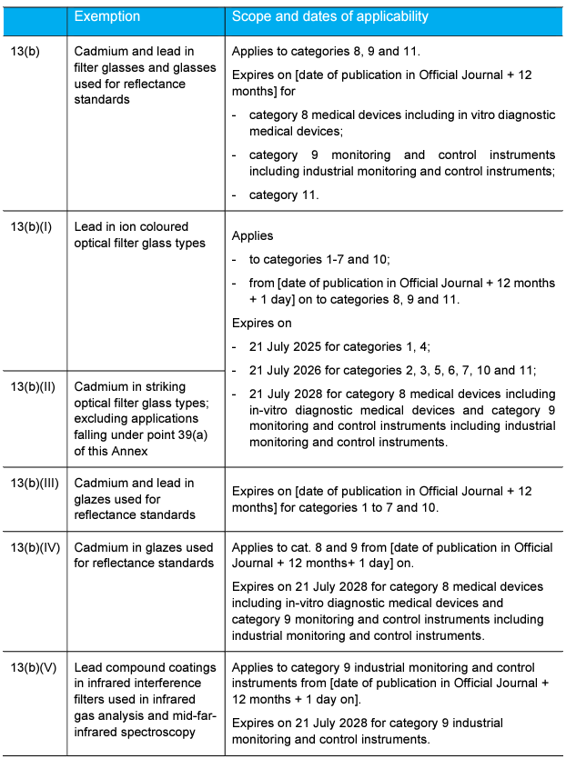
Source: Deubzer et al. (2022)
The European Commission (COM) have not yet officially published their decision as to the adoption of the above recommendation. The COM wishes the consultants to assess in this current review round whether there are any substantial reasons in line with Art. 5(1)(a) against the adoption of the above recommendation for EEE of categories 8, 9 and 11 (RoHS Annex I). This implies that the consultants will assess whether the validities of exemptions whose renewal is requested for cat. 8, 9 or 11 may exceed the validities recommended in the previous review (Table 2). Table 3 reflects the potential scope and wording if exemption III-13b is renewed for cat. 9 IMCI.
Table 3: Renewal of exemption 13b for cat. 9 IMCI
No. | Recommended Exemption | Recommended scope and dates of applicability
III-13b | Cadmium and lead in filter glasses and glasses used for reflectance standards | Applies to categories 8, 9 and 11.  Expires on [date of publication in Official Journal + 12 months] for  - category 8 medical devices including in vitro diagnostic medical devices;  - category 9 monitoring and control instruments including industrial monitoring and control instruments;  - category 11.
III-13(b)(I) | Lead in ion coloured optical filter glass types | Applies to categories 1-7 and 10 from [date of publication in Official Journal + 12 months + 1 day] on to categories 8, 9 and 11.  Expires on  - 21 July 2025 for categories 1, 4;  - 21 July 2026 for categories 2, 3, 5, 6, 7, 10 and 11;  - 21 July 2028 for category 8 medical devices including in-vitro diagnostic medical devices;  - 21 July 2028 for category 9 monitoring and control instruments other than industrial monitoring and control instruments;  - 21 July [2028 + X] for category 9 industrial monitoring and control instruments.
III-13(b)(II) | Cadmium in striking optical filter glass types; excluding applications falling under point 39(a) of this Annex
13(b)(III) | Cadmium and lead in glazes used for reflectance standards | Expires on [date of publication in Official Journal + 12 months] for categories 1 to 7 and 10.
13(b)(IV) | Cadmium in glazes used for reflectance standards | Applies to cat. 8 and 9 from [date of publication in Official Journal + 12 months+ 1 day] on.  Expires on  - 21 July 2028 for category 8 medical devices including in-vitro diagnostic medical devices;  - 21 July 2028 for category 9 monitoring and control instruments other than industrial monitoring and control instruments;  - 21 July [2028 + X] for category 9 industrial monitoring and control instruments.
13(b)(V) | Lead compound coatings in infrared interference filters used in infrared gas analysis and mid-far-infrared spectroscopy | Applies to category 9 industrial monitoring and control instruments from [date of publication in Official Journal + 12 months + 1 day on].  Expires on 21 July [2028 + X] for category 9 industrial monitoring and control instruments.
*X can be a maximum of 3 years

Questions
- In their answers to the clarification questionnaire, TMC claim that the recommendations of Deubzer et al. (2022) which are specified in Table 3 are not applicable to cat. 9 IMCI. It is understood that the arguments against the adoption of the recommended wording for exemption 13b are based on additional administrative burdens which this may cause, while TMC members have difficulty understanding how the recommended rewording / splitting of exemption 13b would lead to greater protection of human health and the environment compared to the wording in its current form. TMC do not specifically address any technical obstacles that might arise if the recommended wording was adopted for.
- Do you agree or disagree with TMC’s reasoning? Please substantiate your response with arguments.
- Do you agree that this exemption is required for cat. 9 IMCI for the applied for validity period until 2031? Please provide arguments and evidence for your opinion.
- Are you aware of cadmium- and lead-free substitutes being used in EEE of cat. 9 IMCI in applications that are in the scope of the requested exemption?

- TMC provided a socio-economic analysis related to the impacts of non-renewal of exemption III-13b for EEE of category 9 IMCI. The document is available online in the consultation folder for this exemption. Do you agree with the underlying method, data and conclusions?

- Is there any additional information which you would like to provide?
Please note that answers to these questions can be published on the stakeholder consultation website and in the review report. If your answers contain confidential information, please provide a version that can be made public along with a confidential version, in which proprietary information is clearly marked.
Please do not forget to provide your contact details (Name, Organisation, e-mail and phone number) so that the project team can contact you in case there are questions concerning your contribution.
It would be helpful for the review process if you could kindly provide the information in formats that allow copying text, figures and tables to be included in the review report.

It is implemented through the specific contract 070201/2020/832829/ENV.B.3 under the Framework contract ENV.B.3/FRA/2019/0017
Directive 2011/65/EU (RoHS) available at http://eur-lex.europa.eu/LexUriServ/LexUriServ.do?uri=CELEX:32011L0065:EN:NOT
Consultation web page: https://rohs.biois.eu/requests2b.html
C.f. BioIS, https://www.rohs.biois.eu/RoHS_Pack-23_Report_Final_20221220.pdf

