Consultation Questionnaire Exemption 6(b) of RoHS Annex III
Table 1: Currently valid wordings of the exemption 6(b) series
No. | Exemption | Scope and dates of applicability
III-6(b) | Lead as an alloying element in aluminium containing up to 0,4 % lead by weight | Applies to categories 8, 9 and 11, and expires on  - 21 July 2021 for cat. 8 other than in-vitro diagnostic medical devices, and cat. 9 other than industrial monitoring and control instruments  - 21 July 2023 for category 8 in-vitro diagnostic medical devices  - 21 July 2024 for category 9 industrial monitoring and control instruments, and for category 11
III-6(b)(I) | Lead as an alloying element in aluminium containing up to 0,4 % lead by weight, provided it stems from lead-bearing aluminium scrap recycling | Expires on 21 July 2021 for categories 1-7 and 10
III-6(b)(II) | Lead as an alloying element in aluminium for machining purposes with a lead content up to 0,4 % by weight | Expires on 18 May 2021 for categories 1-7 and 10

Acronyms and Definitions
Cat. Category, referring to the categories of EEE specified in Annex II of the current RoHS Directive
COM European Commission
EEE Electrical and electronic equipment
IMCI Industrial monitoring and control instruments
Lead-free Not containing lead in the applications in the scope of the exemption to be reviewed
Pb Lead

Background and objectives of this review
Bio Innovation Service, UNITAR-SCYCLE and Fraunhofer IZM have been appointed by the European Commission for the evaluation of applications for new exemptions and the renewal of exemptions currently listed in Annexes III and IV of the RoHS Directive 2011/65/EU.
TMC requested the renewal of exemption 6(b) with its current wording for the maximum validity of seven years for cat. 9 industrial monitoring and control instruments (IMCI). EUROMOT request the renewal of exemptions 6(b)(I) and 6(b)(II) for the maximum valdity period of five years respectively. The National Association of Manufacturers (NAM) support EUROMOTS request.
The applicants were requested to respond to clarification questionnaires prior to this stakeholder consultation to complete missing information. These questionnaires along with the exemption applications and – if submitted - supporting evidence from other stakeholders are accessible on the consultation web page.
The stakeholder consultation is part of the review process for the exemption request at hand. It addresses third parties – not the applicants – to provide and to evaluate information and evidence according to the criteria listed in Art. 5(1)(a) of Directive 2011/65/EU.
Exemptions 6(b), 6(b)(I) and 6(b)(II) were reviewed by Baron et al. (2022). They recommended maintaining the current exemption 6(b) with the same wording and expiry dates as listed in Table 1. They further on recommended renewing exemptions 6(b)(I) as exemption 6(b)(III), and exemption 6(b)(II) as exemption 6(b)(IV) like listed in the below table.
Table 2: Recommended renewal of the current exemptions 6(b)(I) and 6(b)(II) in the last review in 2021/2022
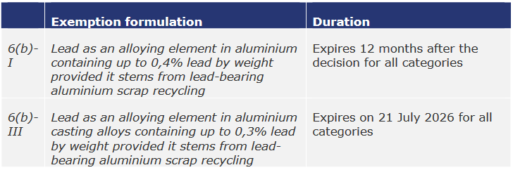
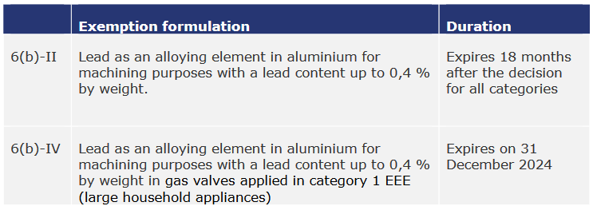
Source: Baron et al. (2022)
The European Commission (COM) have not yet officially published their decision as to the adoption of the above recommendation. The COM wishes the consultants to assess in this current review round whether there are any substantial reasons in line with Art. 5(1)(a) against the adoption of the above recommendation for EEE of categories 8, 9 and 11. This implies that the consultants will assess whether the validities of exemptions whose renewal is requested for cat. 8, 9 or 11 may exceed the validities recommended in the previous review (Table 2). Error! Reference source not found. reflects the potential scope and wordings if the exemptions are renewed for cat. 9 IMCI and for cat. 11.
Table 3: Renewal of current exemption 6(b)(I) and 6(b)(II) for cat. 9 and 11 as exemptions 6(b)(III) and 6(b)(IV) based on the recommendation of Baron et al. (2022)
No. | Recommended Exemption | Recommended scope and dates of applicability
III-6(b) | Lead as an alloying element in aluminium containing up to 0,4 % lead by weight | Applies to categories 8, 9 and 11.  Expires on  - 21 July 2021 for cat. 8 other than in-vitro diagnostic medical devices, and cat. 9 other than industrial monitoring and control instruments  - 21 July 2023 for category 8 in-vitro diagnostic medical devices  - 21 July 2024 for category 9 industrial monitoring and control instruments  - [21 July 2024 + 18 months, or date of official publication of the COM decision + 18 months if the publication date is later than 21 July 2024] for category 11
III-6(b)(III) | Lead as an alloying element in aluminium casting alloys containing up to 0,3 % lead by weight provided it stems from lead-bearing aluminium scrap recycling | Applies to  - categories 1-7 and 10  - category 9 monitoring and control instruments other than industrial monitoring and control instruments from [date of expiry of III-6(b) + 1 day] on  - category 9 industrial monitoring and control instruments from [date of expiry of III-6(b) + 1 day] on  - category 11 from [date of expiry of 6(b) + 1 day] on  Expires on  - 21 July 2026 for categories 1-7 and 10, and for category 9 monitoring and control instruments other than industrial monitoring and control instruments.  - 21 July [2026 + A] for cat. 9 industrial monitoring and control instruments  - 21 July [2026 + C] for cat. 11
III-6(b)(IV) | Lead as an alloying element in aluminium for machining purposes with a lead content up to 0,4 % by weight | Applies to  - gas valves in category 1 from 31 December 2024.  - category 9 monitoring and control instruments other than industrial monitoring and control instruments from [date of expiry of III-6(b) + 1 day] on  - category 9 industrial monitoring and control instruments from [date of expiry of 6(b) for cat. 9 + 1 day] on.  - and cat. 11 from [date of expiry of 6(b) for cat. 11 + 1 day] on  Expires on  - 31 December 2024 for category 1  - 21 July [2024 + B] for cat. 9 industrial monitoring and control instruments  - 31 July [2024 + D] for cat. 11
A and D can be 5 years maximum.
B can be 7 years maximum.
C can be 3 years maximum
Note: Exemption 6(b)(IV) could be renewed as 6(b)(II) as well. The wording of exemption 6(b)(IV) in the above Table 3 is identical to the wording of the current exemption 6(b)(II) after the shift of the “gas valves applied in category 1” from the exemption wording by Baron et al. (2022) in Table 2 to the exemption scope. The consultants will follow up on this in the further review of the exemption requests.

To contribute to this stakeholder consultation, please answer the below questions until 11 December 2023.
Please also see the applicants’ request form and clarification questionnaire response and – if submitted – further information on the consultation web page.

Questions
Baron et al. (2022) state that the 0.3 % for lead in exemption 6(b)(III) is adapted to the current market situation and closes the door to alloys with higher lead contents that remain available on the market but do not serve a functional purpose. EN standardisation processes for aluminium alloys and international standards for aluminium alloys already have lead thresholds below 0.4 % Although no exact data for lead content in the international supply chain is known, the consultant believes that the limit value of 0.3% can be complied with internationally, because a lead content of 0.35 % has already been specified in the international standards since 2007. Thus, the availability of suitable aluminium alloys is assumed to be given. EU Aluminium supported reducing the maximum lead limit to 0.3 %
- In their answers to the clarification questionnaire EUROMOT do not agree that exemption 6(b)(III) would cover their applications in EEE of cat. 11. They claim that up to 0.4 % of lead concentration are still required rather than the 0.3 % of lead permitted in exemption 6(b)(III). EUROMOT members still use aluminium parts with up to 0.4 % of lead in special types of engines some of which are sold in only small numbers. Stocks of parts for these special types of engines may last for up to seven years before they are consumed, and new batches of parts are obtained. Some of the parts currently in stock contain between 0.3 % and 0.4 % lead. With exemption 6(b)(III) becoming applicable instead of the current 6(b)(I), these parts will become waste which has a considerable environmental impact.
  - In the light of the above, do you support EUROMOT’s claim that exemption 6(b)(III) does not cover their members’ needs? Can’t it be reasonably assumed that the members started compliance efforts in the past already so that they are ready to comply with exemption 6(b)(III) by the time it expires in 2026?

  - Do you know of any applications of relevance for devices produced by EUROMOT members where exemption 6(b)(III) can already - or at latest can be – complied with by July 2026?

  - Vice versa, are you aware of applications where this is scientifically and technically still impracticable?

- EUROMOT agree that exemption 6(b)(IV) covers their applications of lead instead of exemption 6(b)(II). They requested that exemption 6(b)(IV) remains valid for 5 years beyond 2024 (i.e. D = 5 years in Table 3). They state that this time is necessary to undertake essential testing as outlined in section 7 of their exemption renewal request.

- In their answers to the clarification questionnaire, TMC insist that exemption 6(b) shall be renewed for cat. 9 IMCI as requested in their exemption renewal application, and that exemptions 6(b)(III) and 6(b)(IV) are not applicable. They justify their statement with additional administrative burdens arising from changes in exemption architectures and numberings and provide technical arguments for the renewal of exemption 6(b) without specifically addressing technical obstacles that might arise if exemption 6(b)(III) with its reduced lead content (0.3 % instead of 0.4 %) became applicable to cat. 9 IMCI. TMC indicate in their exemption renewal request that the content of lead in aluminium applied in cat. 9 IMCI is lower than 0.04 %.

  - In the light of the statements of Baron et al. (2022), do you support TMC’s claim that exemption 6(b)(III) does not cover their members’ needs? Can’t it be reasonably assumed that the members started compliance efforts in the past already so that they are ready to comply with exemption 6(b)(III) by the time it expires in 2026?

  - Do you know of any applications of relevance for devices produced by TMC members (cat. 9 IMCI) where exemption 6(b)(III) can already - or at latest can - be complied with by July 2026?

  - Vice versa, are you aware of applications where this is scientifically and technically still impracticable?

- TMC provided a socioeconomic analysis related to the above exemption request. The document is available online in the consultation folder for this exemption.
Do you agree with the underlying method, data and conclusions?

- Is there any additional information which you would like to provide?

Please note that answers to these questions can be published on the stakeholder consultation website and in the review report. If your answers contain confidential information, please provide a version that can be made public along with a confidential version, in which proprietary information is clearly marked.
Please do not forget to provide your contact details (Name, Organisation, e-mail and phone number) so that the project team can contact you in case there are questions concerning your contribution.
It would be helpful for the review process if you could kindly provide the information in formats that allow copying text, figures and tables to be included in the review report.

It is implemented through the specific contract 070201/2020/832829/ENV.B.3 under the Framework contract ENV.B.3/FRA/2019/0017
Directive 2011/65/EU (RoHS) available at http://eur-lex.europa.eu/LexUriServ/LexUriServ.do?uri=CELEX:32011L0065:EN:NOT
C.f. Öko-Institut, https://rohs.exemptions.oeko.info/fileadmin/user_upload/RoHS_Pack_22/RoHS_Pack-22_final_report_amended_February_2022.pdf
Consultation web page: https://rohs.biois.eu/requests2.html

