Consultation Questionnaire Exemption 7(a) of RoHS Annex III

Table 1: Currently valid wording of the exemption
No. | Exemption | Scope and dates of applicability
III-7(a) | Lead in high melting temperature type solders (i.e. lead-based alloys containing 85 % by weight or more lead) | Applies to categories 1 to 11 (except applications covered by point 24 of this Annex) and expires on  - 21 July 2021 for categories 1 to 7 and 10, and for category 8 other than in vitro diagnostic medical devices and cat. 9 other than industrial monitoring and control instruments  - 21 July 2023 for category 8 in vitro diagnostic medical devices;  - 21 July 2024 for category 9 industrial monitoring and control instruments, and for category 11

Acronyms and Definitions
Cat. Category, referring to the categories of EEE specified in Annex II of the current RoHS Directive
COM European Commission
EEE Electrical and electronic equipment
HMPS High melting point solders
IMCI Industrial monitoring and control instrument
Lead-free Not containing lead in the application in scope of the exemption to be reviewed
NRMM Non-road mobile machinery (NRMM)

Background and objectives of this review
Bio Innovation Service, UNITAR-SCYCLE and Fraunhofer IZM have been appointed by the European Commission for the evaluation of applications for new exemptions and the renewal of exemptions currently listed in Annexes III and IV of the RoHS Directive 2011/65/EU.
TMC requested the renewal of exemption 7(a) with its current wording for the maximum validity of seven years for cat. 9 industrial monitoring and control instruments (IMCIs). EUROMOT request the renewal of exemption 7(a) for the maximum valdity period of five years respectively for cat. 11 with a scope that is specified for the applications of its members (Table 2). The National Association of Manufacturers (NAM) support EUROMOT’s request.
Table 2: Requested exemption renewal
No. | Requested exemption | Requested scope and dates of applicability
III-7(a) | Lead in high melting temperature type solders (i.e. lead-based alloys containing 85 % by weight or more of lead) used in engines, engine components and ancillary components and in end-products in which they are used | Applies to category 11 and expires on 21 July 2029 (= 2024 + 5 years)

The applicants were requested to respond to clarification questionnaires prior to this stakeholder consultation to complete missing information. These questionnaires along with the exemption applications and – if submitted - supporting evidence from other stakeholders are accessible on the consultation web page.
The stakeholder consultation is part of the review process for the exemption request at hand. It addresses third parties – not the applicants – to provide and to evaluate information and evidence according to the criteria listed in Art. 5(1)(a) of Directive 2011/65/EU.
Exemption 7(a) was reviewed by Baron et al. (2022), who recommended to renew the exemption as illustrated in the below table.
Table 3: Recommended renewal of exemption 7(a) in the last review in 2022
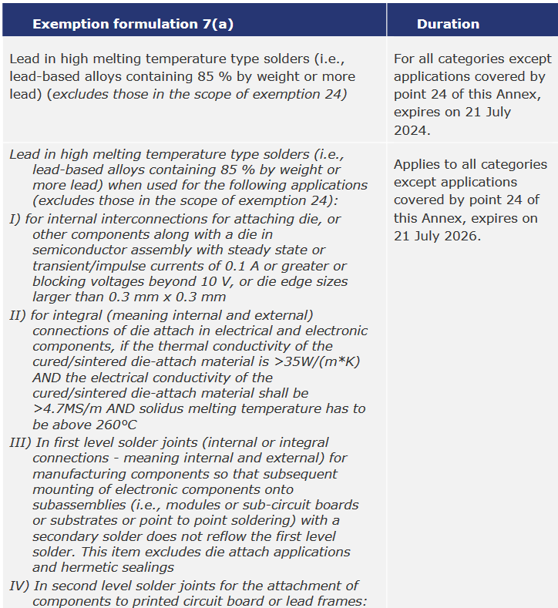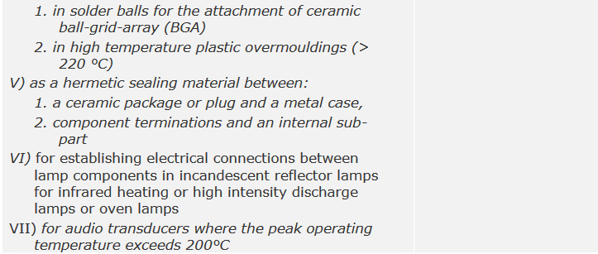
Source: Baron et al. (2022)
The European Commission (COM) have not yet officially published their decision as to the adoption of the above recommendation. The COM wishes the consultants to assess in this current review round whether there are any substantial reasons in line with Art. 5(1)(a) against the adoption of the above recommendation for EEE of categories 8, 9 and 11. This implies that the consultants will assess whether the validities of exemptions whose renewal is requested for cat. 8, 9 or 11 may exceed the validities recommended in the previous review (Table 3). Table 4 reflects the potential scope and wordings if the exemptions are renewed for cat. 9 IMCI and for cat. 11.
Table 4: Renewal of current exemption 7(a) for cat. 9 and 11 based on the recommendation in the last review in 2022
No. | Recommended Exemption | Recommended scope and dates of applicability
III-7(a) | Lead in high melting temperature type solders (i.e., lead-based alloys containing 85 % by weight or more lead) | Applies to all categories but excluding applications covered by exemption 24 of this Annex.  Expires on 21 July 2024 for all categories
III-7(d) | Lead in high melting temperature type solders (i.e., lead-based alloys containing 85 % by weight or more lead) when used for the following applications, excluding those in the scope of exemption 24: | Applies to categories 1 to 11 from 22 July 2024 on.  Expires on  - 21 July 2026 for categories 1 to 8 and 10.  - 21 July [2026 + X] for cat. 11.  - 21 July [2026 + Y] for cat. 9 IMCI.
 | - For internal interconnections for attaching die, or other components along with a die in semiconductor assembly with steady state or transient/impulse currents of 0.1 A or greater or blocking voltages beyond 10 V, or die edge sizes larger than 0.3 mm x 0.3 mm
 | - For integral (meaning internal and external) connections of die attach in electrical and electronic components, if the thermal conductivity of the cured/sintered die-attach material is >35 W/(m*K) AND the electrical conductivity of the cured/sintered die-attach material shall be >4.7 MS/m AND solidus melting temperature has to be above 260°C
 | - In first level solder joints (internal or integral connections - meaning internal and external) for manufacturing components so that subsequent mounting of electronic components onto subassemblies (i.e., modules or sub-circuit boards or substrates or point to point soldering) with a secondary solder does not reflow the first level solder. This item excludes die attach applications and hermetic sealings
- In second level solder joints for the attachment of components to printed circuit boards or lead frames:
- In solder balls for the attachment of ceramic ball-grid-array (BGA)
- In high temperature plastic overmouldings (>220 °C)
- As a hermetic sealing material between:
- A ceramic package or plug and a metal case,
- A component termination and an internal sub-part
 | - For establishing electrical connections between lamp components in incandescent reflector lamps for infrared heating or high intensity discharge lamps or oven lamps
 | - For audio transducers where the peak operating temperature exceeds 200 °C
X can be maximum 3 years
Y can be maximum 5 years
To contribute to this stakeholder consultation, please answer the below questions until 11 December 2023.
Please also see the applicants’ request form and clarification questionnaire response and – if submitted – further information on the consultation web page.

Questions
- EUROMOT state in their answers to the clarification questionnaire that the scope of exemption 7(d) is likely to be too restrictive for their members uses of high melting point solders (HMPS). EUROMOT members are not able to determine if all lead-high melting point solders are captured by the proposed 7(d) as they use a wide variety of electronic components utilising exemption 7(a), but electronics suppliers do not provide information as to whether this is covered by 7(d). EUROMOT therfore request the renewal of exemption 7(a) for five years.
  - Do you agree to the above reasoning?

  - The proposed exemption 7(d) is not intended to restrict the scope compared to exemption 7(a) where no lead-free alternatives are available but to specify the applications where HMPS is used.
Do you know of any applications of HMPS in cat 11 or other categories which exemption 7(d) would not cover?

- TMC do not agree to the proposed exemption wordings of exemptions 7(d) to be applied to cat. 9 IMCIs. They state that they applied for the renewal of the current exemption 7(a). Lead is a significant ingredient of the solder alloys used to electrically or physically join two elements. High Melting Point (HMP) solders are used for a wide variety of applications. Based on the application type, a lead amount of >85% is required to achieve the necessary melting temperature and to obtain other material properties.
There is no single substitute available that would be suitable for all the applications identified and match the technical performance of lead. Currently, substitutes for even the major uses have rarely been found. Evaluating alternatives for each of the niche uses would take an enormous amount of time and resources, with little probability of success. TMC therefore apply for the renewal of exemption 7(a) for the maximum renewal period.
  - Do you agree to the above reasoning?

  - The proposed exemption 7(d) is not intended to restrict the scope compared to exemption 7(a) where no lead-free alternatives are available but to specify the applications where HMPS is used.

  - Do you know of any applications of HMPS in cat cat. 9 IMCIs which exemption 7(d) would not cover?

- Looking at all categories of EEE (1 to 11): Are you aware of any applications of lead in the scope of the current exemption 7(a) that require the use of lead but would not be covered by the scope of the recommended exemption 7(d)?

- As part of the evaluation, socio-economic impacts shall also be compiled and evaluated. For this purpose, if you have additional information on socioeconomic aspects that are expected to arise if the exemption is not granted as requested by EUROMOT, please provide details in respect of the following:
  - What are the volumes of EEE in the scope of the requested exemptions which are placed on the market per year?

  - What are the volumes of additional waste to be generated should the requested ex-emption not be renewed or not be renewed for the requested duration?

  - What are estimated impacts on employment in total, in the EU and outside the EU, should the requested exemption not be renewed or be renewed for less than the re-quested time period? Please detail the main sectors in which possible impacts are expected – manufacturers of equipment in the scope of the exemption, suppliers, re-tail, users of MRI devices, etc.

  - Please estimate additional costs associated should the requested exemption not be renewed, and how this is divided between various sectors (e.g. private, public, industry: manufacturers, suppliers, retailers).

- TMC provided a socioeconomic analysis related to the above exemption request. The document is available online in the consultation folder for this exemption.
Do you agree with the underlying method, data and conclusions?

- Any additional information which you would like to provide?

Please note that answers to these questions can be published on the stakeholder consultation website and in the review report. If your answers contain confidential information, please provide a version that can be made public along with a confidential version, in which proprietary information is clearly marked.
Please do not forget to provide your contact details (Name, Organisation, e-mail and phone number) so that the project team can contact you in case there are questions concerning your contribution.
It would be helpful for the review process if you could kindly provide the information in formats that allow copying text, figures and tables to be included in the review report.

It is implemented through the specific contract 070201/2020/832829/ENV.B.3 under the Framework contract ENV.B.3/FRA/2019/0017
Directive 2011/65/EU (RoHS) available at http://eur-lex.europa.eu/LexUriServ/LexUriServ.do?uri=CELEX:32011L0065:EN:NOT
C.f. Öko-Institut, https://rohs.exemptions.oeko.info/fileadmin/user_upload/RoHS_Pack_22/RoHS_Pack-22_final_report_amended_February_2022.pdf
Consultation web page: https://rohs.biois.eu/requests2.html

