Consultation Questionnaire
Exemption 1(a) of RoHS Annex IV
Table 1 shows the current wording of the exemption on Annex IV of the RoHS Directive.
Table 1: Currently valid wording of exemption IV-1a
No. | Current exemption wording | Current scope and dates of applicability
IV-1(a) | Lead and cadmium in ion selective electrodes including glass of pH electrodes | Applies to categories 8 and 9.  Expires on  - 21 July 2021 for cat. 8 other than in-vitro diagnostic medical devices, and cat. 9 other than industrial monitoring and control instruments  - 21 July 2023 for category 8 in-vitro diagnostic medical devices  - 21 July 2024 for category 9 industrial monitoring and control instruments

ACRONYMS AND DEFINITIONS
COM European Commission
EEE Electrical and electronic equipment
IVD In-vitro diagnostic medical devices

Background and objectives of this review
Bio Innovation Service, UNITAR-SCYCLE and Fraunhofer IZM have been appointed by the European Commission for the evaluation of new exemptions and the renewal of exemptions currently listed in Annexes III and IV of the RoHS Directive 2011/65/EU.
COCIR requested the renewal of exemption IV-1a with the proposed wording “Lead & cadmium in thick film pastes, in ion selective electrodes used for blood gas systems” until August 2026 for cat. 8 in-vitro diagnostic medical devices (IVD). The applicants were requested to respond to a clarification questionnaire prior to this stakeholder consultation to provide missing information. This questionnaire along with the exemption applications, and – if submitted – supporting evidence from other stakeholders, are accessible on the consultation web page.
The stakeholder consultation is part of the review process for the exemption request at hand. It addresses third parties – not the applicants – to collect and to evaluate information and evidence according to the criteria listed in Art. 5(1)(a) of Directive 2011/65/EU.
To contribute to this stakeholder consultation, please answer the below questions until 11 December 2023.
Please also see the applicants’ request form and clarification questionnaire response and – if submitted – further information on the consultation web page.

Summary of the exemption renewal request
COCIR provided the following summary for their renewal request: “Blood gas analysis systems use ion selective electrodes in their sensors, to detect blood gases such as pO2 and pCO2 and biomarkers in patients blood. Blood gas systems are used to accurately diagnose various conditions such as asthma, chronic obstructive pulmonary disease (COPD), kidney failure, uncontrolled diabetes and severe infections, as well as treat patients in respiratory and/or metabolic distress. Lead and cadmium are constituents of thick film screen printable paste used in the sensors. These constituents are used to promote reaction bonding and for ensuring strong adhesion of the paste base metal (typically gold or palladium) to the ceramic substrate material on firing. A planar sensor array can contain up to 10 sensors, with performance integral to the reliability, sensitivity and quick response time of the system. With the sensors themselves reliant on the integrity of the connections formed by the thick film paste. For good connections to be made the paste is required to have a precise viscosity to allow for the printing of fine features and low resistivity (≤ 4.5mΩ @ 10µm) which is determined by the percent solids, the ability to form a dense film with minimal defects and good adhesion to the substrate. Testing is still ongoing for alternative RoHS compliant thick film pastes, with a focus on alternatives developed by the same manufacturer to minimise the changes to the technical characteristics of the paste, and thus reduce the timeframes for qualification. Alternative technologies which avoid the use of thick film pastes are possible but would require additional time to qualify alternatives due to more major product design and production process changes. In addition to these changes, the many decades of experience and reliability data gathered while using thick film pastes would also have to be overcome, resulting in considerably longer timeframes for qualification.”

Exemption 1a was reviewed by Deubzer et al. (2022) resulting in the below recommendation of two options: exemption wording option A and option B.
Table 2: Proposed renewal of exemption 1a in the last review in 2022
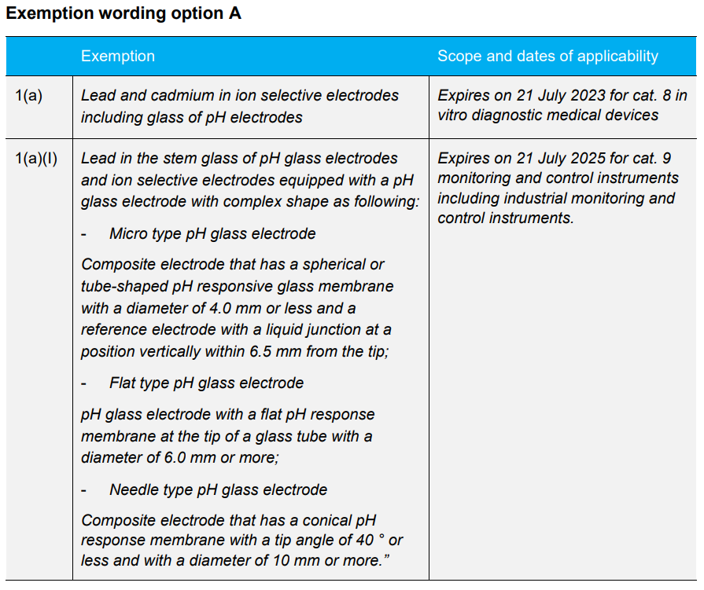
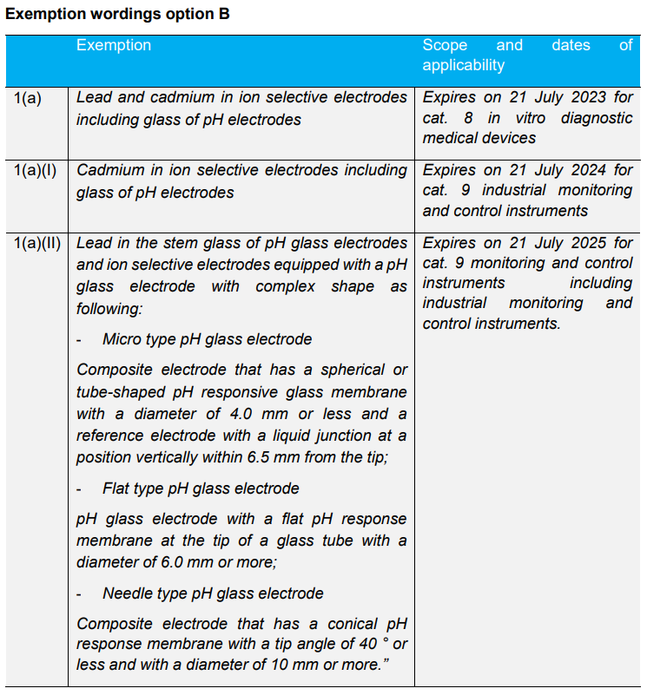
Source: (Deubzer et al. 2022)
The European Commission (COM) have not yet officially published their decision as to the adoption of the above recommendation. The COM wishes the consultants to assess in this current review round whether there are any substantial reasons in line with Art. 5(1)(a) against the adoption of the above recommendation for EEE of categories 8, 9 and 11 (RoHS Annex I). This implies that the consultants will assess whether the validities of exemptions whose renewal is requested for cat. 8, 9 or 11 may exceed the validities recommended in the previous review (Table 2). Table 3 reflects the potential scope and wording if exemption IV-1a is renewed for cat. 8 IVD, reflecting the above wording option A. Table 4 reflects wording option B.

Table 3: Renewal of exemption 1a for cat. 8 IVD reflecting wording option A
No. | Exemption | Scope and dates of applicability
IV-1a | Lead and cadmium in ion selective electrodes including glass of pH electrodes | Expires on 21 July 2023
IV-1a(I) | Lead in the stem glass of pH glass electrodes and ion selective electrodes equipped with a pH glass electrode with complex shape as following:  - Micro type pH glass electrode  Composite electrode that has a spherical or tube-shaped pH responsive glass membrane with a diameter of 4.0 mm or less and a reference electrode with a liquid junction at a position vertically within 6.5 mm from the tip;  - Flat type pH glass electrode  pH glass electrode with a flat pH response membrane at the tip of a glass tube with a diameter of 6.0 mm or more;  - Needle type pH glass electrode  Composite electrode that has a conical pH response membrane with a tip angle of 40° or less and with a diameter of 10 mm or more.” | Applies to cat. 8 in vitro diagnostic medical devices and cat. 9 monitoring and control instruments including industrial monitoring and control instruments from 22 July 2023, respectively.  Expires on  - 22 July [2023 + X*] for cat. 8 in vitro diagnostic medical devices.  - 21 July 2025 for cat. 9 monitoring and control instruments including industrial monitoring and control instruments.
*X can be a maximum of 7 years
Table 4: Renewal of exemption 1a for cat. 8 IVD reflecting wording option B
No. | Exemption | Scope and dates of applicability
IV-1a | Lead and cadmium in ion selective electrodes including glass of pH electrodes | Expires on 21 July 2023.
IV-1a(I) | Cadmium in ion selective electrodes including glass of pH electrodes | Applies to cat. 8 in vitro diagnostic medical devices and cat. 9 monitoring and control instruments including industrial monitoring and control instruments from 22 July 2023, respectively.  Expires on  - 21 July [2023 + X*] for cat. 8 in vitro diagnostic medical devices.  - 21 July 2024 for cat. 9 industrial monitoring and control instruments.
IV-1a(II) | Lead in the stem glass of pH glass electrodes and ion selective electrodes equipped with a pH glass electrode with complex shape as following:  - Micro type pH glass electrode  Composite electrode that has a spherical or tube-shaped pH responsive glass membrane with a diameter of 4.0 mm or less and a reference electrode with a liquid junction at a position vertically within 6.5 mm from the tip;  - Flat type pH glass electrode  pH glass electrode with a flat pH response membrane at the tip of a glass tube with a diameter of 6.0 mm or more;  - Needle type pH glass electrode  Composite electrode that has a conical pH response membrane with a tip angle of 40 ° or less and with a diameter of 10 mm or more.” | Applies to cat. 8 in vitro diagnostic medical devices and cat. 9 monitoring and control instruments including industrial monitoring and control instruments from 22 July 2023, respectively.  Expires on  - 22 July [2023 + X*] for cat. 8 in vitro diagnostic medical devices.  - 21 July 2025 for cat. 9 monitoring and control instruments including industrial monitoring and control instruments.
*X can be a maximum of 7 years

Questions
- In their answers to the clarification questionnaire, COCIR agree that exemption 1a-(I) of Table 4 would cover their applications of cadmium in EEE of cat. 8 IVD, provided that the exemption would remain valid for 7 years, i.e. until 2031.
  - In case you do not agree with COCIR’s above conclusions, please support your views with detailed technical argumentation / evidence in line with the criteria in Art. 5(1)(a).
  - Do you agree that this exemption is required for cat. 8 IVD for another 7 years until 2031, and alternatively until August 2026, as initially requested by COCIR? Please provide arguments and evidence for your opinion.
  - Are you aware of cadmium-free substitutes being used in EEE of cat. 8 IVD in applications that are in the scope of the requested exemption?

- Regarding the use of lead, COCIR claim that the recommendations in Table 2, which are reflected in Table 3 exemption IV-1a(I) and Table 4 exemption IV-1a(II), are not applicable to cat. 8 IVD. It is understood that this disagreement refers to the exemption wording that permits the use of lead only in stem glass of electrodes with specific geometry types, which COCIR claims are not applicable to blood gas systems.
From a technical perspective, the planar sensors that require lead-containing thick film paste according to COCIR are a different technology compared to the glass electrodes for which the exemption wording in Table 2 (and therefore also in Tables 3 and 4) was designed.
  - In case you do not agree with COCIR’s above conclusions, please support your views with detailed technical argumentation / evidence in line with the criteria in Art. 5(1)(a).
  - Do you agree that that exemption is required for cat. 8 IVD until August 2026? Please provide arguments and evidence for your opinion.
  - Are you aware of lead-free substitutes being used in EEE of cat. 8 IVD in applications that are in the scope of the requested exemption?

- Is there any additional information which you would like to provide?

Please note that answers to these questions can be published on the stakeholder consultation website and the review report. If your answers contain confidential information, please provide a version that can be made public along with a confidential version, in which proprietary information is clearly marked.
Please do not forget to provide your contact details (Name, Organisation, e-mail and phone number) so that the project team can contact you in case there are questions concerning your contribution.
It would be helpful for the review process if you could kindly provide the information in formats that allow copying text, figures and tables to be included in the review report.

It is implemented through the specific contract 070201/2020/832829/ENV.B.3 under the Framework contract ENV.B.3/FRA/2019/0017
Directive 2011/65/EU (RoHS) available at http://eur-lex.europa.eu/LexUriServ/LexUriServ.do?uri=CELEX:32011L0065:EN:NOT
Consultation web page: https://rohs.biois.eu/requests2.html
C.f. BioIS, https://www.rohs.biois.eu/RoHS-Pack-21_Final-Report_amended.pdf

