Consultation Questionnaire
Exemption 1b of RoHS Annex IV
Table 1 shows the current wording of the exemption on Annex IV of the RoHS Directive.
Table 1: Currently valid wording of exemption IV-1b
No. | Current exemption wording | Current scope and dates of applicability
IV-1b | Lead anodes in electrochemical oxygen sensors. | Applies to categories 8 and 9.  Expires on  - 21 July 2021 for cat. 8 other than in-vitro diagnostic medical devices, and cat. 9 other than industrial monitoring and control instruments  - 21 July 2023 for category 8 in-vitro diagnostic medical devices  - 21 July 2024 for category 9 industrial monitoring and control instruments

ACRONYMS AND DEFINITIONS
COM European Commission
EEE Electrical and electronic equipment
IMCI Industrial monitoring and control instruments

Background and objectives of this review
Bio Innovation Service, UNITAR-SCYCLE and Fraunhofer IZM have been appointed by the European Commission for the evaluation of new exemptions and the renewal of exemptions currently listed in Annexes III and IV of the RoHS Directive 2011/65/EU.
Four applicants requested the renewal of exemption IV-1b:
- Alphasense requested the renewal of exemption 1b with the proposed wording “Lead anodes in capillary oxygen sensors” until January 2027 for cat. 9 industrial monitoring and control instruments (IMCI) and July 2028 for the same category for ATEX rated products. Alphasense’s exemption request is supported by The Council of Gas Detection and Environmental Monitoring (CoGDEM), TROLEX, AFRISO, ANALOX, fatair, GAS DATA, GDS Technologies, GEMLOG controls, GfG, KANE, AMETEK MOCON, QED, Sensotran, and SEWERIN.
- AMETEK MOCON requested renewal of exemption 1b with the proposed wording “Lead anodes in electrochemical Hersch cells for oxygen sensors for measurement of permeation” until January 2028 for cat. 9 IMCI.
- Dräger requested renewal of exemption 1b with the current wording until the end of 2025 for new instruments that use electrochemical oxygen sensors that contain lead and until 21 July 2031 for replacement oxygen sensors for cat. 9 IMCI.
- Honeywell requested renewal of exemption 1b with the current wording until 21 July 2031 for cat. 9 IMCI.
The applicants were requested to respond to clarification questionnaires prior to this stakeholder consultation to provide missing information. These questionnaires along with the exemption applications, and – if submitted – supporting evidence from other stakeholders, are accessible on the consultation web page.
The stakeholder consultation is part of the review process for the exemption requests at hand. It addresses third parties – not the applicants – to collect and to evaluate information and evidence according to the criteria listed in Art. 5(1)(a) of Directive 2011/65/EU.

Summary of the exemption renewal requests
Alphasense provided the following summary for their renewal request: “Lead is used as the anode in capillary oxygen sensors which are used to measure oxygen gas in the range of 0-30% in fixed installations, personal monitoring devices and permeation measurements, such that an alarm is triggered if the oxygen levels are above or below a set threshold. Capillary sensors have minimal response to pressure, temperature and humidity, while having a short warm-up time and are self-powered. Other sensors, such as amperometric type sensors can be lead-free but are not able to offer these technical characteristics and are susceptible to high carbon monoxide (CO) and carbon dioxide (CO₂) concentrations and cannot be used in the absence of oxygen. Alphasense and other sensor manufacturers have carried out research into substitute metals and none are drop-in replacements as outlined above. More research is needed develop alternative sensors that offer suitable technical performance, after which the design and validation of analyser instruments including performance certification can be undertaken. Depending on the end use in question the level of redesign and testing will vary, with an estimated timeframe of at least 4 years for general applications and at least another 18-months subsequent to this for ATEX rated products.”
AMETEK MOCON provided the following summary for their renewal request: “Lead is used as the anode of a Hersch cell, electrochemical sensor which is used to measure the absolute oxygen permeation in industrial monitoring and control devices. Specifically, Hersch cells are used in the production of pharmaceutical products, medical applications such as wound dressings, assessment of the integrity of food packaging and solar panel lifespan calculations and improvements. Hersch cells can detect oxygen in the range of 200 ppt to 70 ppm and is an absolute method of measurement (Coulometric) which removes the need to calibrate the sensor (which would be impossible to undertake at the extremely low levels of detection it undertakes). Alternative lead-free technologies do not offer the same level of detection range as they require calibration and rely on membranes which limit the sensitivity of the sensor. Alternative lead-free anodes are currently being trialled with some anode/ electrolyte combinations showing initial indications that suitable performance may be achievable. Additional testing of critical performance, followed by reliability and productionisation testing needs to be undertaken to determine if a lead-free solution can offer the required technical performance. As such, although an alternative lead-free solution is being actively sought, it is not yet known if any potential alternative is a viable technical solution and additional time is required to determine this.”
Dräger provided the following summary for their renewal request: “This exemption is necessary to allow the use of electrochemical oxygen sensors to measure oxygen concentration in industrial applications. This primarily includes applications in inerting processes, i.e., when organic vapors or gases occur simultaneously with the oxygen in atmospheres for monitoring the lower explosion limit of industrial processes. Lead-containing organic capsules are intrinsically safe here, as they cannot act as a source of ignition, like potential lead-free sensors with electrodes made of platinum black. The latter generate their working potential via a potentiostat circuit and not via a natural potential gradient between the lead and the gold of the working electrode, as is the case with galvanic oxygen sensors. A shift of the reference potential due to penetrating gases from the sensor environment leads here to a failure of the sensor.”
Honeywell provided the following summary for their renewal request: “Honeywell is submitting this exemption renewal request for lead in oxygen sensors because the recent Pack 21 review did not consider the types of sensor and end-uses that are described here. Oxygen concentrations in gases can be measured using a variety of methods but each has advantages and disadvantages. For some end-uses, such as small portable gas monitors and instruments that can operate in ATEX environments, only instruments with galvanic sensors are suitable and usually only lead anode sensors can be used. One of the advantages of lead anode sensors are that they do not consume electricity so small battery powered portable instruments can be used for whole working shifts. Also, the electrical characteristics of lead anode sensors are different to all other types of oxygen sensors, so alternative types cannot be used as drop-in replacements in existing instrument designs. Research has been carried out with potential substitute anode materials, but all have been found to have disadvantages, the main one being that lead is the only suitable anode metal that does not self-corrode or passivate under any conditions inside the sensor. Research into substitute sensor/instrument options is being carried out by Honeywell, but due to the need for approvals for many of the end-uses, this will take many years to complete.”

Exemption 1b was reviewed by Deubzer et al. (2022) resulting in the below recommendation.
Table 2: Proposed renewal of exemption 1b in the last review in 2022
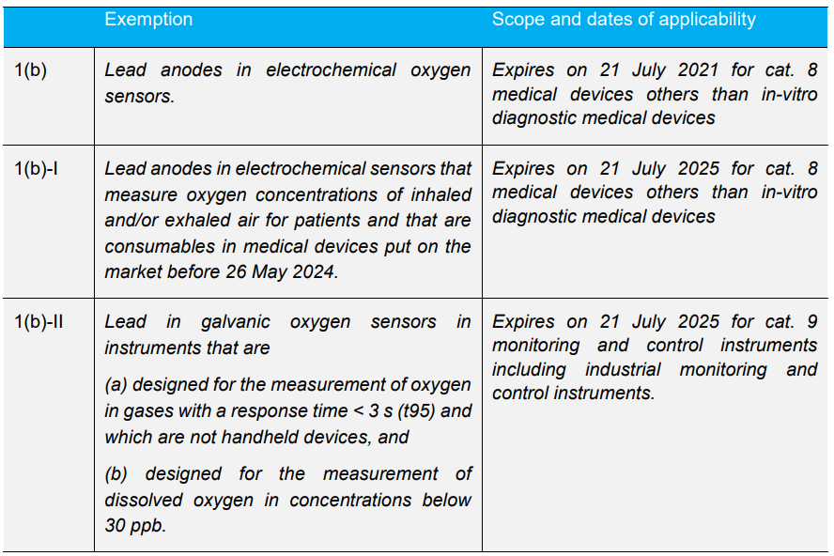
Source: (Deubzer et al. 2022)
The European Commission (COM) have not yet officially published their decision as to the adoption of the above recommendation. The COM wishes the consultants to assess in this current review round whether there are any substantial reasons in line with Art. 5(1)(a) against the adoption of the above recommendation for EEE of categories 8, 9 and 11 (RoHS Annex I). This implies that the consultants will assess whether the validities of exemptions whose renewal is requested for cat. 8, 9 or 11 may exceed the validities recommended in the previous review (Table 2). Table 3 reflects the potential scope and wording if exemption IV-1b is renewed for cat. 9 IMCI.
Table 3: Renewal of exemption 1b for cat. 9 IMCI
No. | Exemption | Scope and dates of applicability
IV-1(b) | Lead anodes in electrochemical oxygen sensors. | Applies to cat. 8 medical devices other than in vitro diagnostic medical devices.  Expires on 21 July 2021.
IV-1(b)(I) | Lead anodes in electrochemical sensors that measure oxygen concentrations of inhaled and/or exhaled air for patients and that are consumables in medical devices put on the market before 26 May 2024. | Applies to cat. 8 medical devices other than in vitro diagnostic medical devices from 22. July 2021.  Expires on 21 July 2025.
IV-1(b)(II) | Lead in galvanic oxygen sensors in instruments that are  (a) designed for the measurement of oxygen in gases with a response time < 3 s (t95) and which are not handheld devices, and  (b) designed for the measurement of dissolved oxygen in concentrations below 30 ppb. | Applies to cat. 9 monitoring and control instruments including industrial monitoring and control instruments.  Expires on  - 21 July 2025 for cat. 9 monitoring and control instruments other than industrial monitoring and control instruments.  - 21 July [2025 + X*] for cat. 9 industrial monitoring and control instruments.
*X can be a maximum of 7 years

To contribute to this stakeholder consultation, please answer the below questions until 11 December 2023.
Please also see the applicants’ request form and clarification questionnaire response on the consultation web page.

Questions
- In their answers to the clarification questionnaire, all applicants claim that the recommendations of Deubzer et al. (2022) in Table 2 which are reflected in Table 3 are not applicable to cover equipment of cat. 9 IMCI in scope of their renewal requests:
    - Alphasense claim products in scope of their exemption renewal request (capillary sensors) are not characterized as having a response time below 3 seconds and that the technical difference between capillary sensors and those outlined in 1b-II in Table 3 are substantial, stating that “capillary sensors are able to measure to 20ppb and have other critical performance characteristics which include the ability to operate at 0% oxygen, minimal response to temperature and pressure and wide operating temperature range. The full list of technical parameters is outlined on page 6 of the renewal request.”
    - AMETEK MOCON claim products in scope of their exemption renewal request (Hersch cells) are not characterized as having a response time below 3 seconds, but that “other technical parameters differentiate the unique technical performance of Hersch cells, including the sensor being an absolute method of measurement and thus being able to achieve such low levels of detection [it is stated it can measure to 200 ppt]. The full list of differentiating technical parameters are outlined in the renewal submission on page 5.”
    - Dräger claim that the recommended exemption wording “does not cover the use of these electrochemical sensors as consumables/spare parts in industrial monitoring and control instruments that will be placed on the market before the expiry of the current exemption on 21st July 2024 or at the end of the requested exemption on 31st December 2025.” and “Exemption IV-1b-II as shown in Table 4 does not cover Dräger electrochemical sensors”
    - Honeywell claim products in scope of their exemption renewal request (capillary cells and membrane diffusion cells) are not characterized as having a response time below 3 seconds, adding that “The concentration range of oxygen measurement ranges between 0% to 100%, rather than the 30 ppb of dissolved O₂ which is not applicable to gas sensors outlined in 1b-II.”
- Do you agree or disagree with any of the applicants’ above conclusions? Please support your views with detailed technical argumentation / evidence in line with the criteria in Art. 5(1)(a).
- Do you agree that this exemption is required for cat. 9 IMCI for the applied validity periods? Please provide arguments and evidence for your opinion.
- Are you aware of lead-free substitutes being used in EEE of cat. 9 IMCI in applications that are in the scope of the requested exemption?

- The applicant Dräger defines oxygen sensors that are used to replace spent oxygen sensors in existing instruments as ‘spare parts’. According to RoHS Article 3(27), ‘spare part’ means a separate part of an EEE that can replace a part of an EEE. The EEE cannot function as intended without that part of the EEE. The functionality of EEE is restored or is upgraded when the part is replaced by a spare part. According to RoHS Art. 4(4)(f), RoHS substance restrictions shall not apply to spare parts of EEE which benefited from an exemption and which was placed on the market before that exemption expired as far as that specific exemption is concerned.
- Do you agree with the definition of replacement oxygen sensors as ‘spare parts’? Please substantiate your response with arguments.
- Do you agree with the applicant’s request for a renewal of the exemption specifically for replacement oxygen sensors, for the maximum validity period? Please substantiate your response with arguments.
- Printer ink cartridges are considered as ‘consumables’ according the the RoHS 2 FAQ document (question 7.4). Do you have arguments that replacement oxygen sensors should be considered ‘consumables’ rather than ‘spare parts’?

- Is there any additional information which you would like to provide?

Please note that answers to these questions can be published on the stakeholder consultation website and the review report. If your answers contain confidential information, please provide a version that can be made public along with a confidential version, in which proprietary information is clearly marked.
Please do not forget to provide your contact details (Name, Organisation, e-mail and phone number) so that the project team can contact you in case there are questions concerning your contribution.
It would be helpful for the review process if you could kindly provide the information in formats that allow copying text, figures and tables to be included in the review report.

It is implemented through the specific contract 070201/2020/832829/ENV.B.3 under the Framework contract ENV.B.3/FRA/2019/0017
Directive 2011/65/EU (RoHS) available at http://eur-lex.europa.eu/LexUriServ/LexUriServ.do?uri=CELEX:32011L0065:EN:NOT
C.f. BioIS, https://www.rohs.biois.eu/RoHS-Pack-21_Final-Report_amended.pdf
Consultation web page: https://rohs.biois.eu/requests2.html
RoHS 2 FAQ document https://ec.europa.eu/environment/pdf/waste/rohs_eee/faq.pdf

